Python_Problem_Statement _5_Anup_Patil

**Write a Python function that accepts a string and calculates the number of uppercase letters and lowercase letters.**

Sample String: 'The quick Brow Fox'

Expected Output :

No. of Upper case characters : 3

No. of Lower case Characters: 12

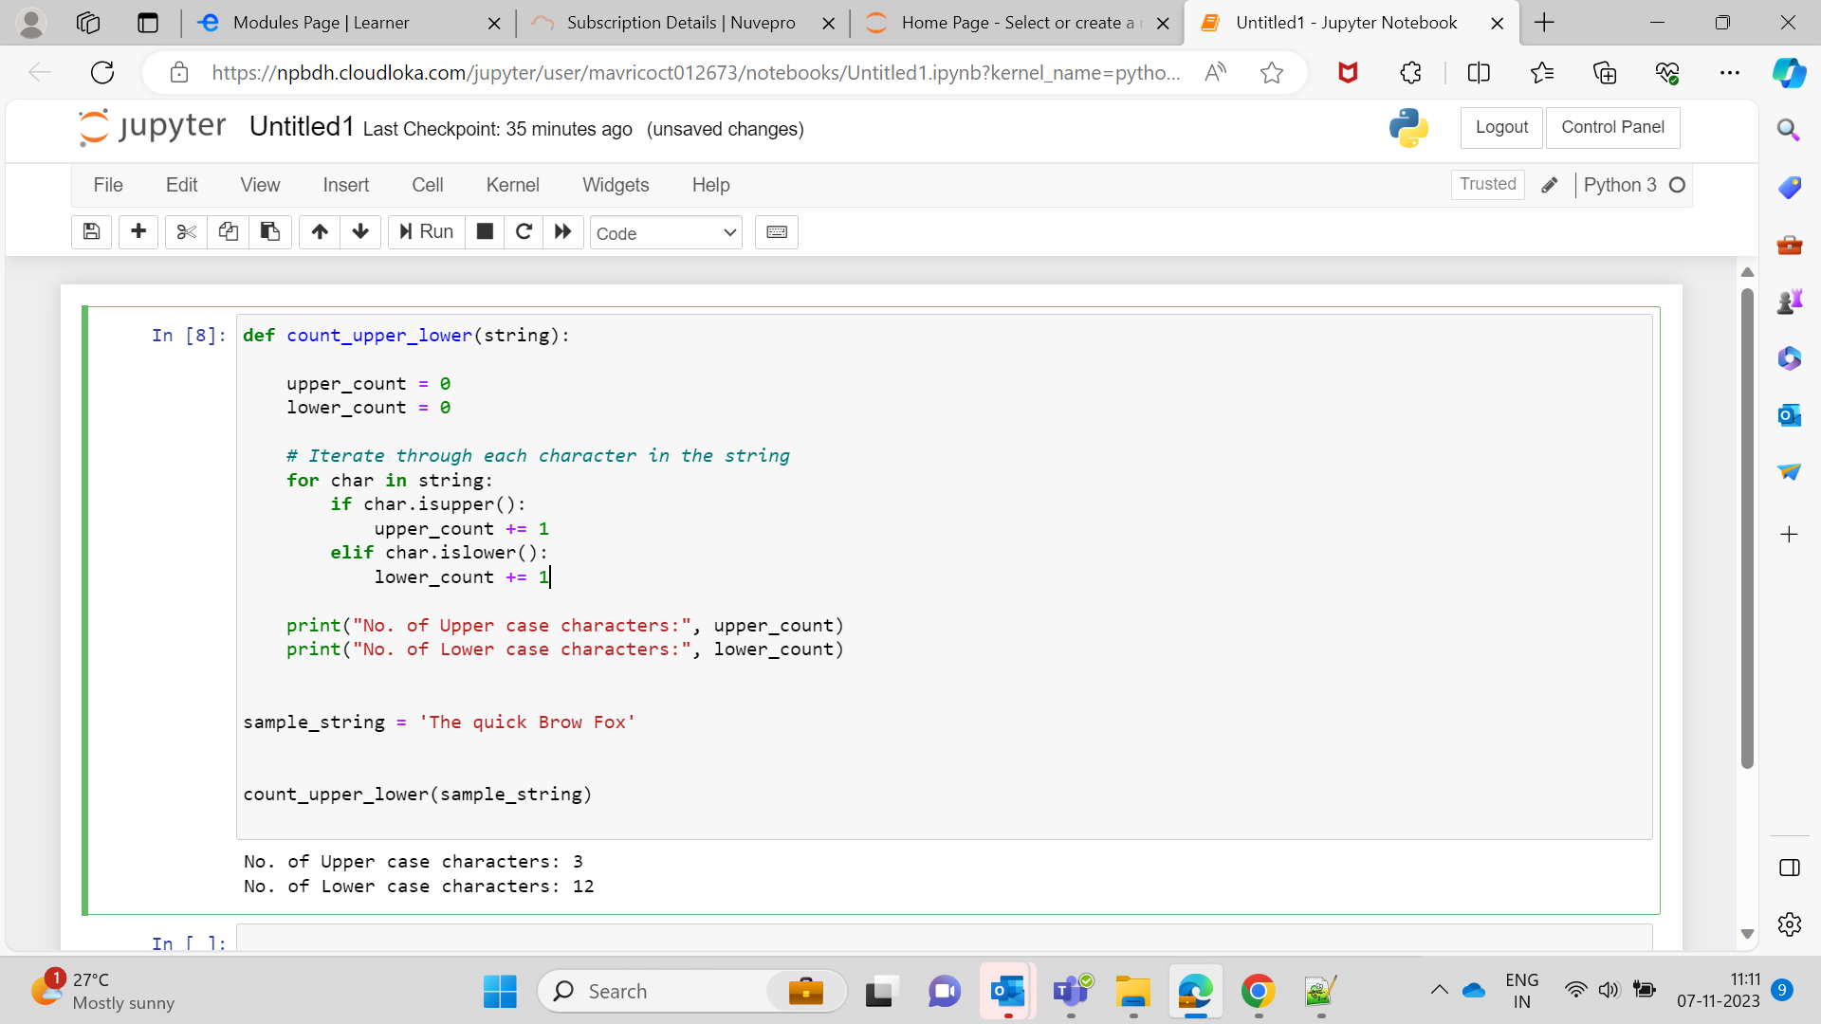  
  
def count_upper_lower(string):

upper_count = 0

lower_count = 0

# Iterate through each character in the string

for char in string:

if char.isupper():

upper_count += 1

elif char.islower():

lower_count += 1

print("No. of Upper case characters:", upper_count)

print("No. of Lower case characters:", lower_count)

sample_string = 'The quick Brow Fox'

count_upper_lower(sample_string)